The Gabriel Bialy, State-of-the-Art Lectureship in Reproductive Physiology

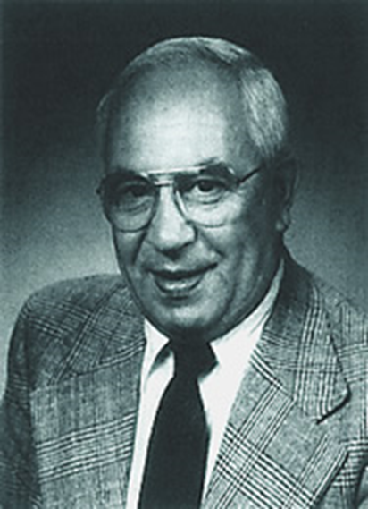

Born in Poland, Bialy came to the United States after World War II where he received his undergraduate degree from Ohio State University and his doctorate from the University of Wisconsin.
In 1959, he joined the laboratory of Gregory Pincus at the Worcester Foundation for Experimental Biology in Shrewsbury, Massachusetts, where he performed a wide variety of studies in reproductive physiology, with a particular emphasis on the pharmacological actions of steroid hormones. During that period, he was a member of the research team that developed the first oral contraceptive.
It was at the Worcester Foundation where Drs. Gabriel Bialy, Do Won Hahn, and Andrzej Bartke formed a career long friendship.
In 1971, Bialy moved to NIH, where he joined the National Institute of Child Health and Human Development (NICHD) as a health scientist administrator in the Contraceptive Development Branch. He was named branch chief in 1975, a position he held until becoming deputy director of the Center for Population Research in the early 1990s, he remained active in NIH administration until his death making him one of the institute’s longest-serving staff members.
During his career, he authored or co-authored numerous papers on reproductive biology, reproductive pharmacology and contraceptive development as well as stewarding a number of research collaborations, in particular between American and Indian researchers to further studies to improve reproductive health and maternal and child health in India.
Dr. Do Won Hahn established the Gabriel Bialy Lecture in Reproductive Biology in 2001 to recognize Dr. Bialy's contributions to the field of reproductive biology and his service as a program official at NICHD.
This lectureship was established in the Department of Physiology at the SIU School of Medicine by Dr. Hahn to honor his friend and colleague, Dr. Andrzej Bartke, who was then chairman of the Physiology Department and a renowned reproductive biologist. Dr. Bialy passed away on Feb. 17, 2009, but we continue to honor his contributions to reproductive biology research through this annual lectureship.

Past Lecturers
2002 JoAnne Richards
2003 John Peluso
2004 Michael Soares
2005 Jay Cross
2006 Larry Jameson
2007 Jon Levine
2008 Teresa Woodruff
2009 Sally Camper
2010 Michael Griswold
2011 R. Michael Roberts
2012 Geula Gibori
2013 Blanche Capel
2014 Mary Hunziker-Dunn
2015 Ursula Kaiser
2016 Kelly Mayo
2017 Asgerally Fazleabas
2018 John McCarrey
2021 Martin Kelly
2022 Sue Moenter
2023 Thaddeus Golos

